Patching Procedure

Pre-patching Tasks:

1. If not done already, create a new “Content View” for the month. Each Content View will be used across all environments during each patching cycle, starting with Non-Prod:
2. Log into RH Satellite at <https://p01nsvl-asatl01.corp.lpl.com/>
3. Ensure the ‘Organization’ is set to “LPL Financial Services”: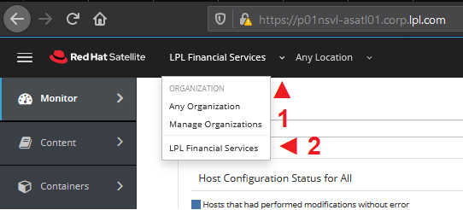
4. Go to “Content” > “Content Views”: 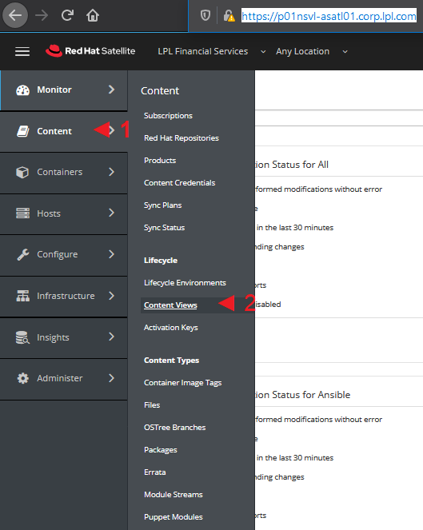
5. Select the blue “Create New View” button located far right: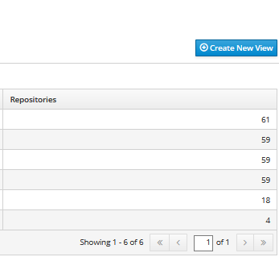
6. Name and Label the new “Content View” (Format: Month Year).
7. Go to “Yum Content” > “Repositories”: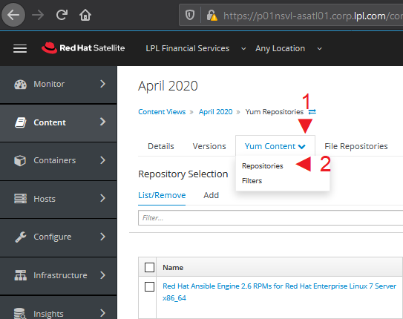
8. Select only the repositories we wish to apply for that particular Content View. (This step requires further discussion in order to obtain an exact list.)
9. Select the blue “Publish New Version” button located far right: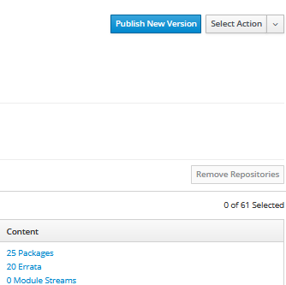
10. Promote the new Content View to the applicable environment. Non-Prod is QA*/DEV* and PROD is production.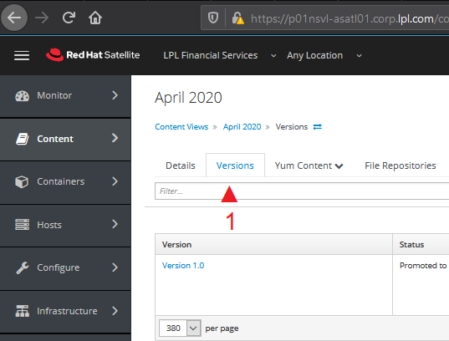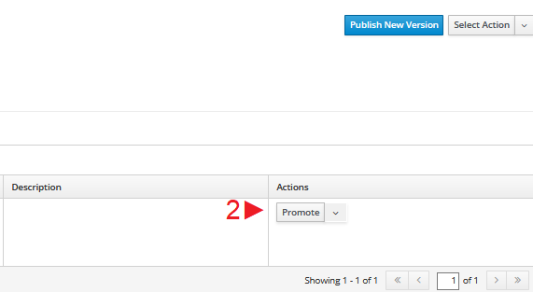
11. Fetch the servers to be patched by going to “Hosts” > “Content Hosts”. For this you’ll be required to prepare a search string that’ll pull an accurate server list from RH Satellite. RM will be circulating emails containing environment tags that should help you accomplish that: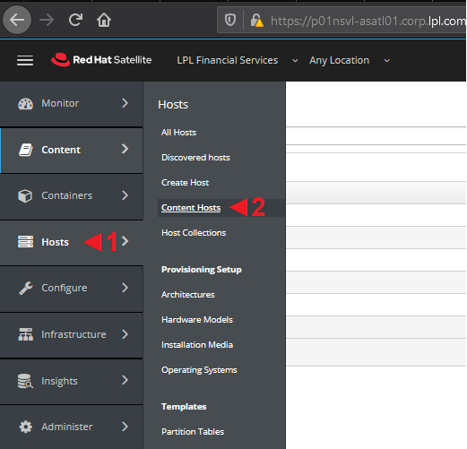 * Note: If the target servers are in production but the Content View is promoted to Non-Prod only, another promotion has to happen from Non-Prod to PROD. Patching activity should happen on Non-Prod servers before that Content View can be promoted to PROD.
12. For this example, we’re targeting only database servers in the **QAF0/QAF1/QAF3/QAF5/QAF6/QAPerf/DEV** environments. To accomplish that we used “Development or QAF* or QAP* or QA-perf or NEWQAP not QAF2 not QAF4 and database“. Enter the search string in the filter field: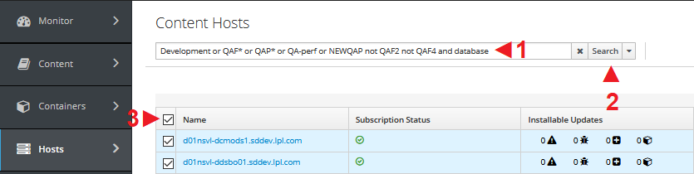
13. Assign the new Content View to the target servers by going to the “Select Action” drop down menu and selecting “Change Lifecycle Environment”: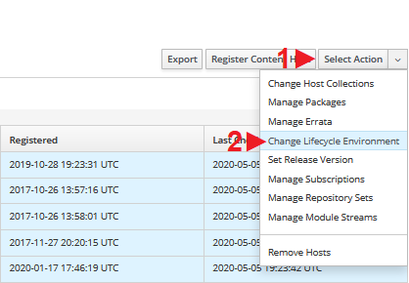
14. Select the appropriate environment (Non-Prod is QA*/DEV* and PROD is production.), and the newly created Content View, then select “Assign” and “Yes” on the next prompt and finally verify the change in the “Content View” column: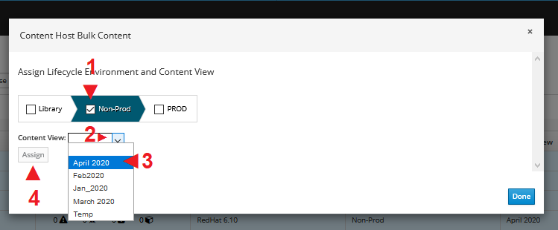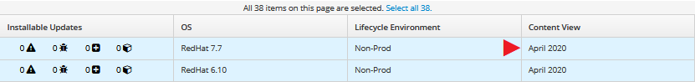
15. Export a server list that can be used to verify subscription status is “Fully Entitled” and also that can be saved into the jump server p00nsvl-altls01 for running loops: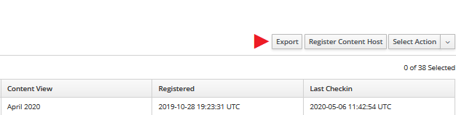 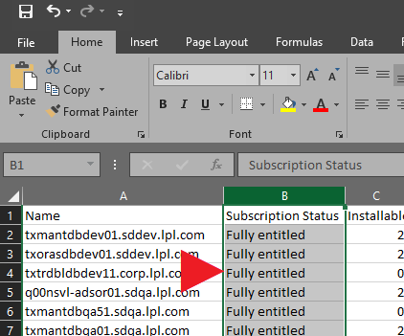
16. Make sure subscriptions are locked to the proper RHEL version (Run: # subscription-manager release –show):

* All RHEL6 servers should be locked to RHEL 6.10 release version.
* All RHEL7 servers (except MapR) should be locked to RHEL 7.7 release version.
* All MapR servers should be locked to RHEL 7.6 version release version.
* All EDM Informatica servers should be locked to RHEL 7.5.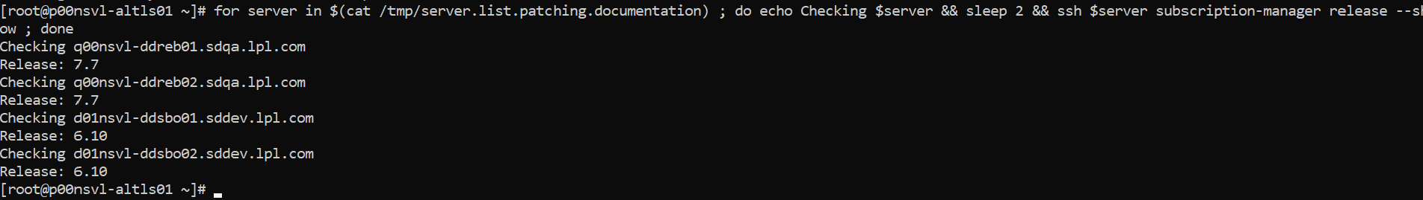
* If any server is not locked to the proper RHEL version, set it correctly by running: # subscription-manager release –set=7.7 # Change version accordingly.

1. Refresh RH Satellite subscription on each server. This can be done by either scheduling a remote job from Satellite, or by writing a ‘for’ or ‘while’ loop to SSH into each server and run the necessary command: # subscription-manager refresh
   1. Go to “Hosts” > “All Hosts”: 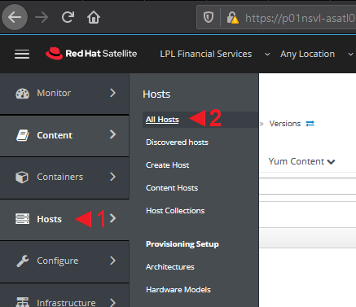
   2. Enter the search string in the filter field, select search and select all servers: 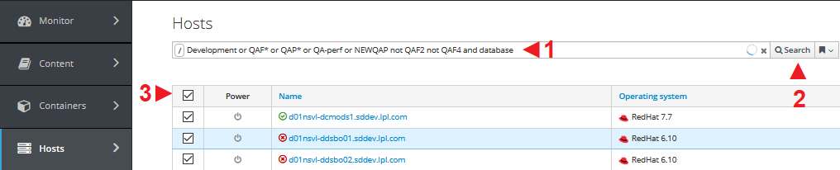
   3. Go to the “Select Action” drop down menu located far right and select “Schedule Remote Job”: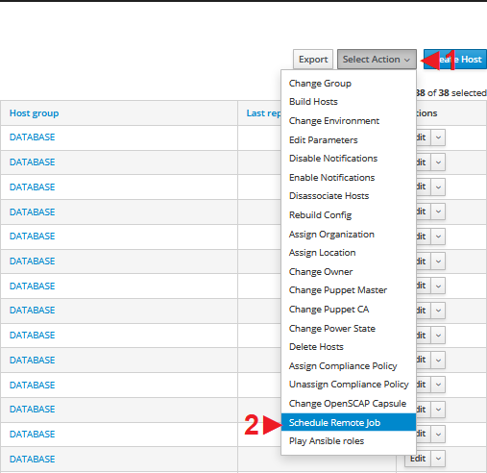
   4. Go to the “Job Category” drop down menu and select “Commands”. Enter “subscription-manager refresh” in the “command” field, ensure the “Schedule” is set to “Execute Now”, and select “Submit”: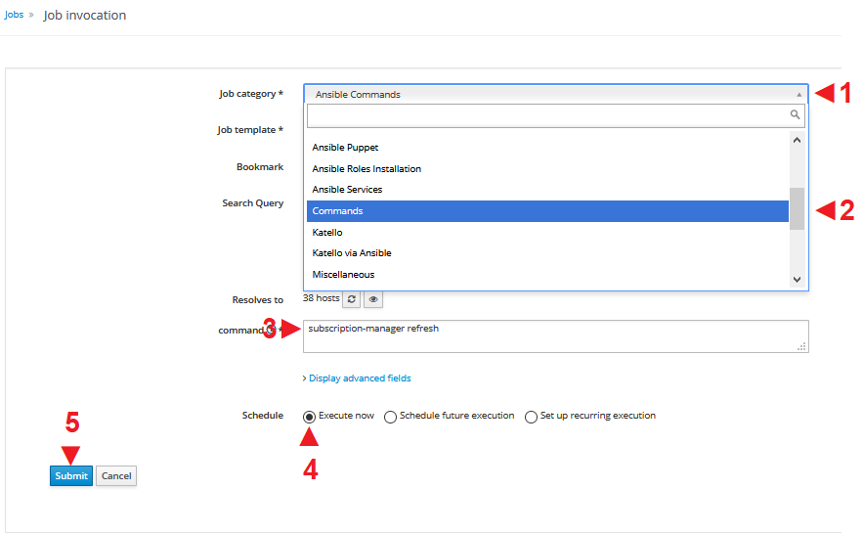
   5. Make sure each server has enough disk space by running “df” in a loop. We want to pay close attention to /var particularly.

Patching Tasks:

1. Run: # subscription-manager refresh; rm -rf /var/cache/yum; yum clean all; yum repolist
2. Run: # yum update --exclude=kernel* --disablerepo=* --enablerepo=rhel-*-server-rpms,rhel-*-for-rhel-*-server-rpms,rhel-*-server-satellite-tools-6.5-rpms –y
3. Run: # yum update kernel* --disablerepo=* --enablerepo=rhel-*-server-rpms,rhel-*-for-rhel-*-server-rpms,rhel-*-server-satellite-tools-6.5-rpms –y
4. Run: # reboot
5. Databases and applications MUST be down before reboots. Reboot database servers first.
6. For Tibco servers, reboot odd numbered servers first, even numbered servers afterwards.
7. For Tibco servers inside QAPerf (F01*), stop cluster service on even numbered servers after reboot with: # pcs cluster stop
8. Servers inside QAPerf (F01*) are isolated. Only accessible from jump server f01nsvl-acaps01
9. Tibco servers have a mount point named “/GFS” that must be checked for read,write access after rebooting. Run: # touch /GIFS/UnixTeamTest
10. Verify installed packages via yum log: # tail /var/log/yum.log